**ASSIGNMENT 29.2**

**Problem Statement:**

Write a hive UDAF to find the largest integer in a column. Use your own dataset for the above problem statement and attach the steps performed, codes used with the result.

**Solution:**

**UDAF class:**

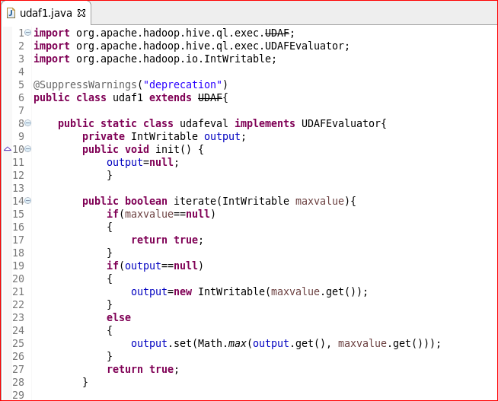

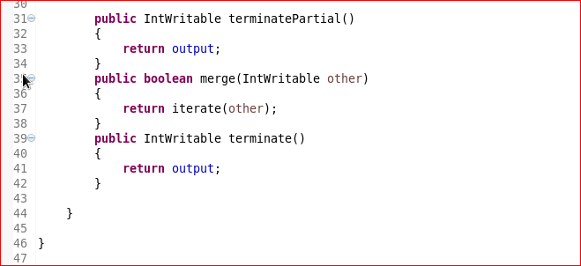

**Creating table and loading data into table:**

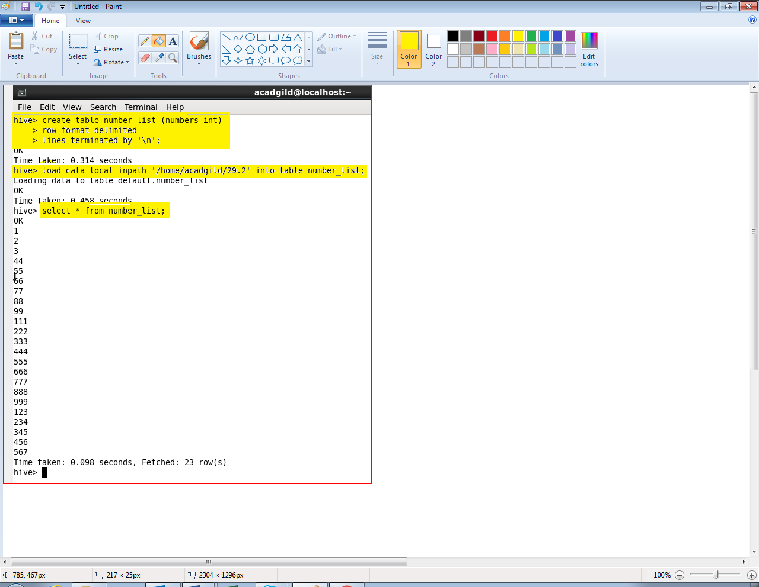

**Adding jar and creating temporary function:**

